**COLLAGE MODULE:-**

* Collage admin user creation using self-sign on.
* After filling the details click on create tab.

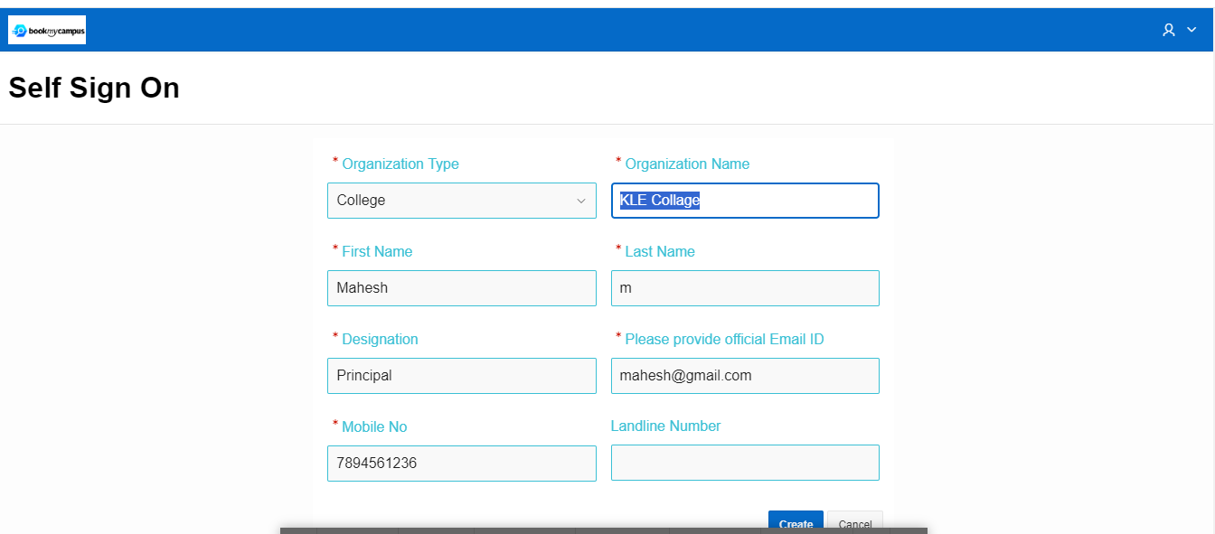

* Once create tab is clicked following screen will appear saying ‘Request Received. Please check your email ’. Accordingly check user mail and login through link.

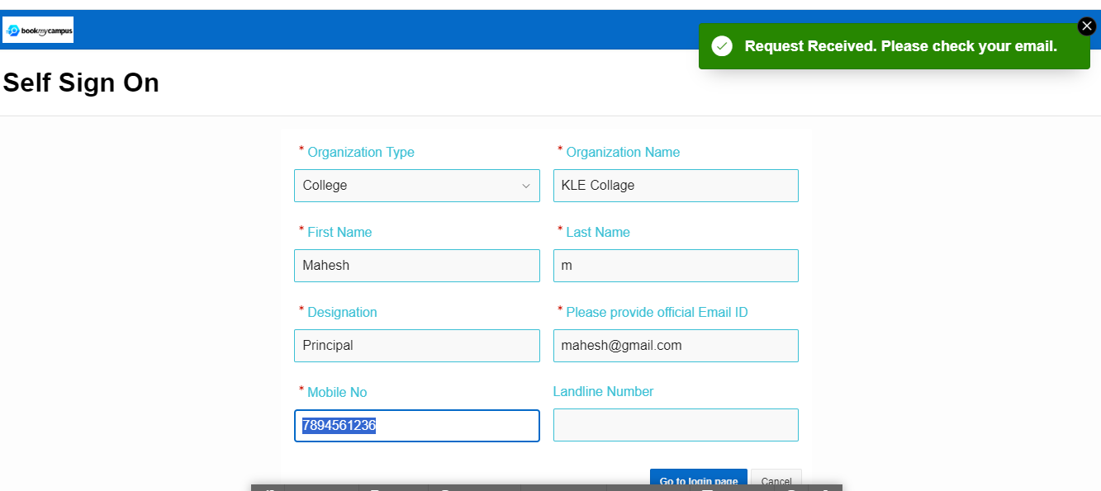

* Key in the Register Mobile number and enter the OTP received on the mobile number which was mention during self-sign on user creation.
* Click on Sign In.

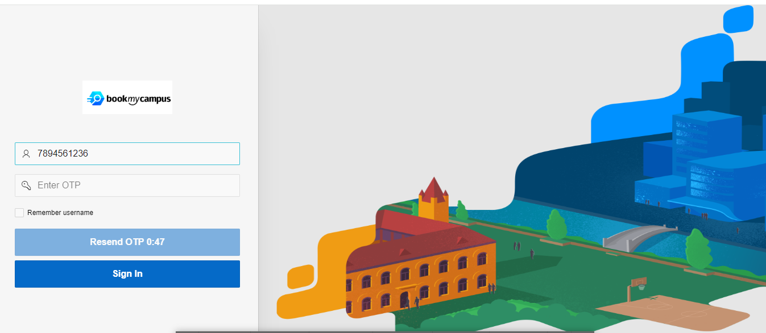

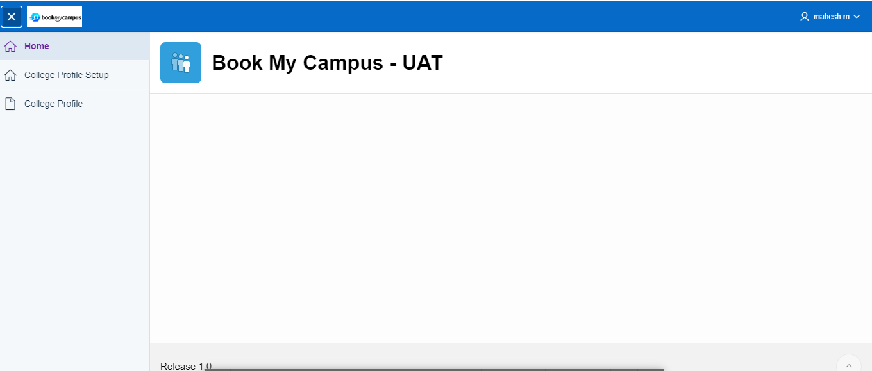

* At this stage Collage Profile needs to be created by Keying in all the details as per the different tabs – (Collage and campus information, location and contact details, Collage Logistics & Hospitality Facilities, Collage Pictures & Other details).

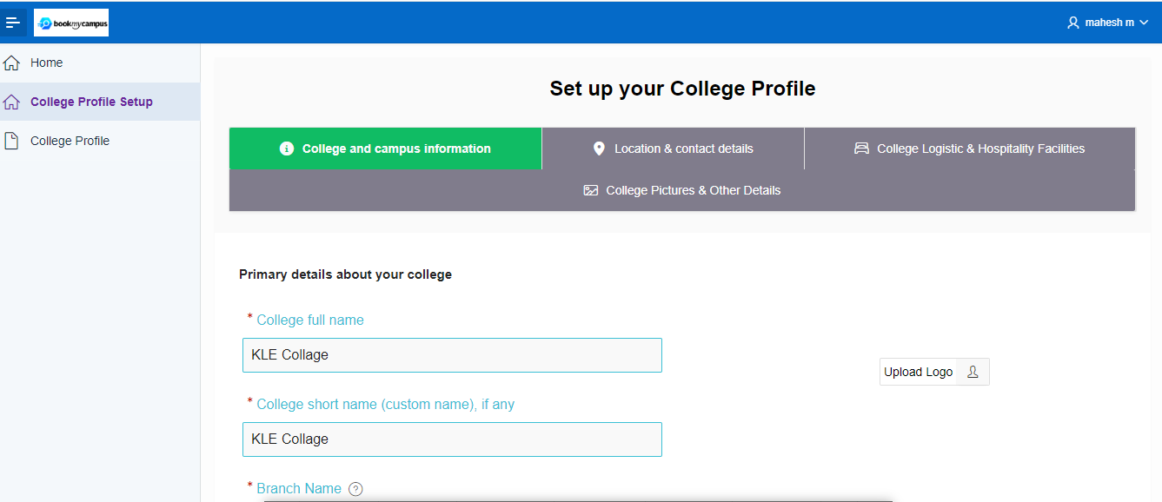

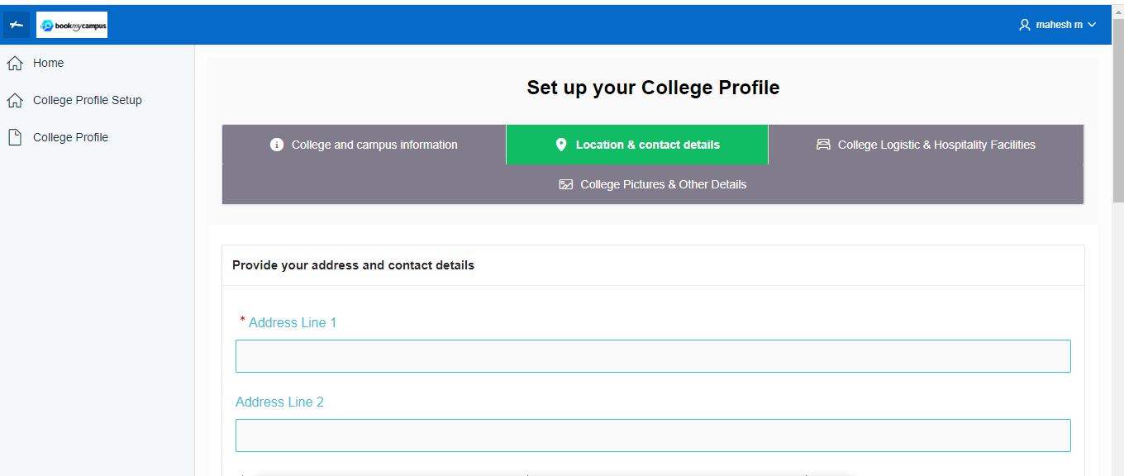

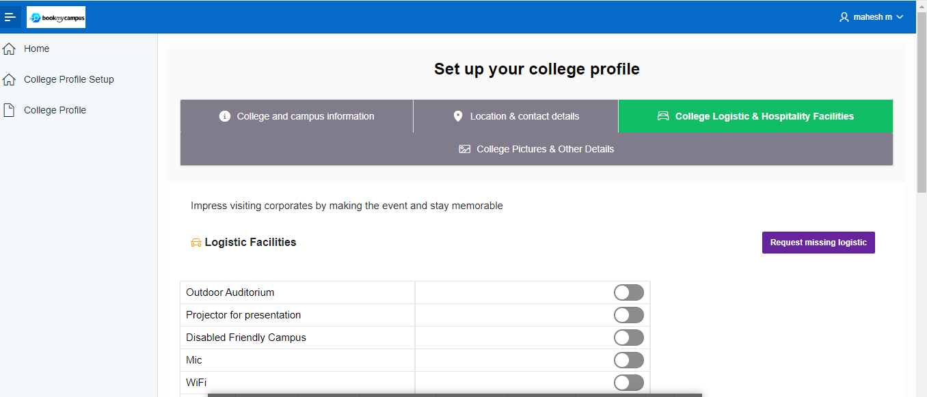

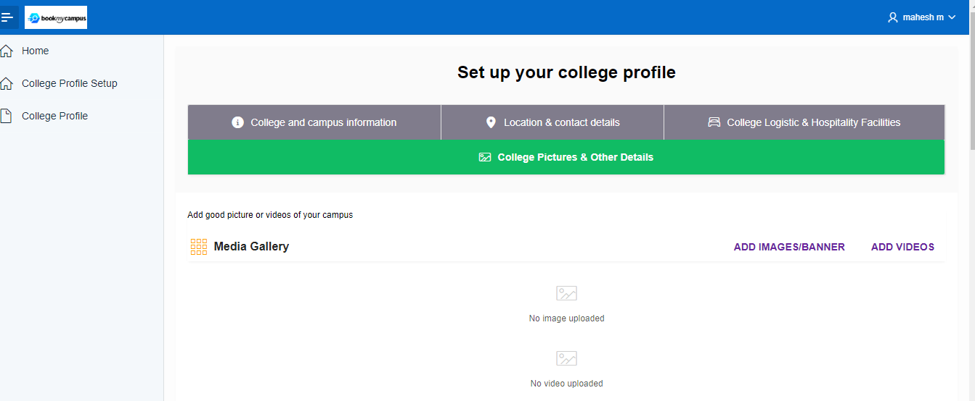

* After keying in all the details for all the tabs click on Finish Button.

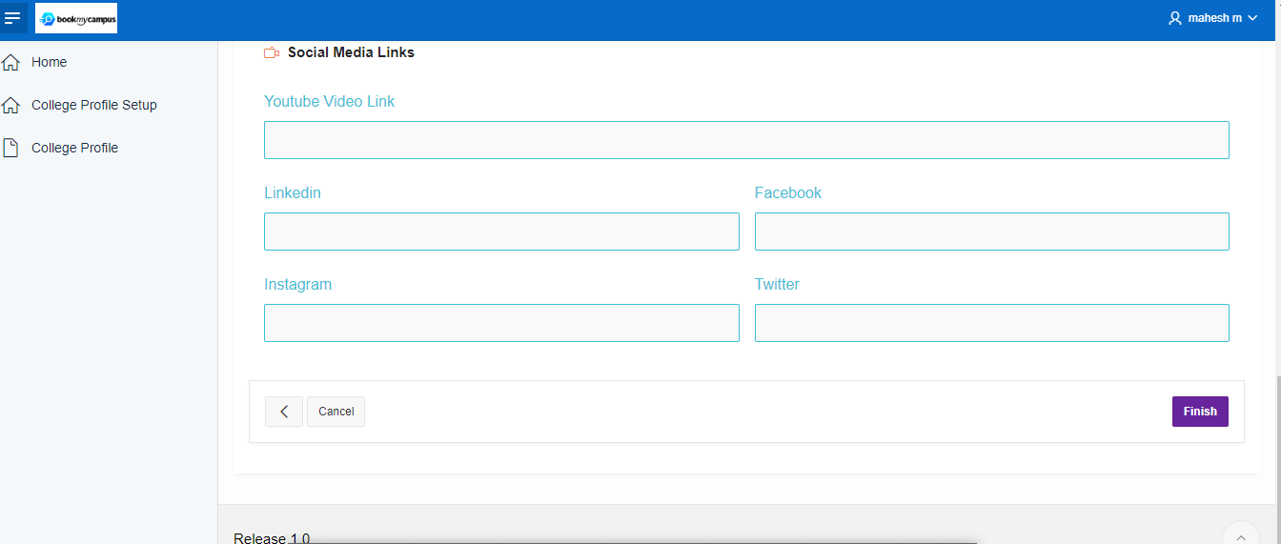

* College profile successfully saved.

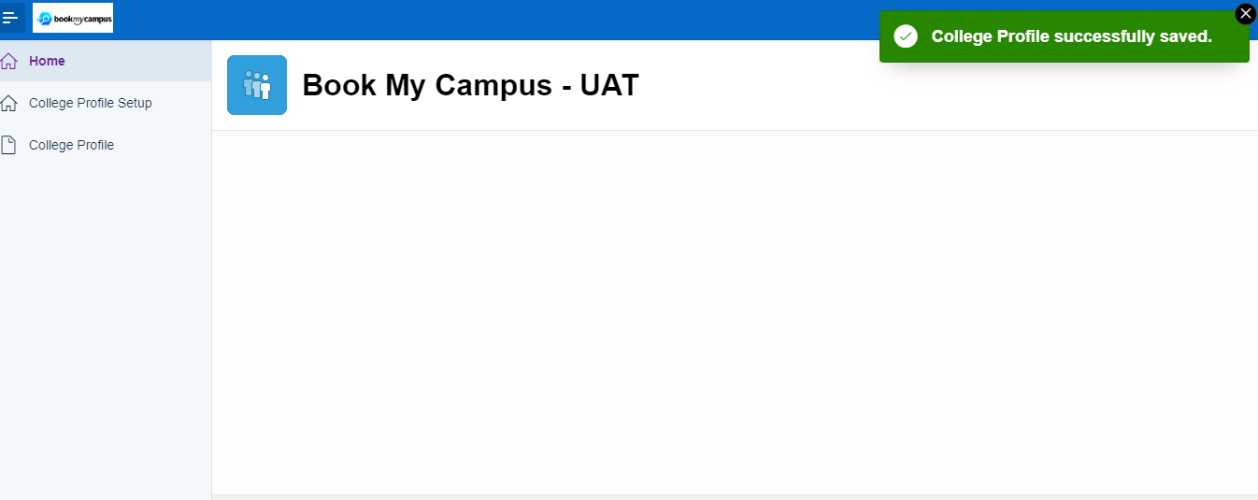

* Once Collage profile is created, email & mobile notifications will go to BMC admin user for review and approval where BMC Admin can approve or reject.

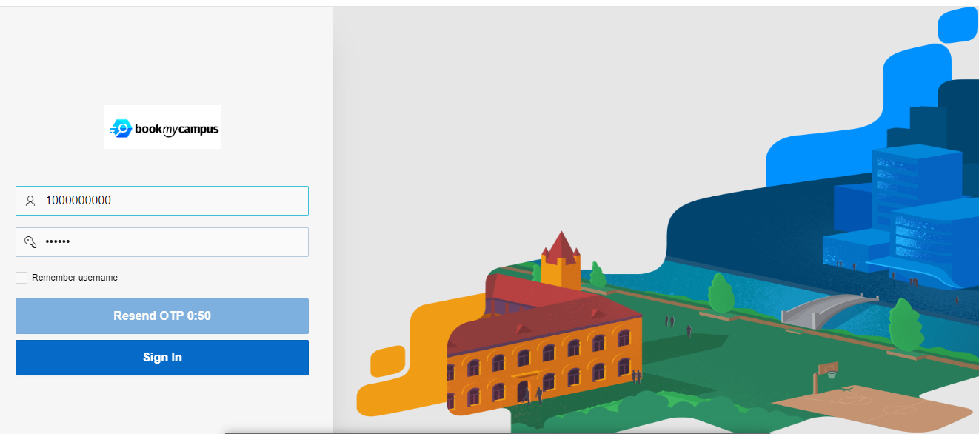

* BMC system admin will click on Accept or Reject as shown below.

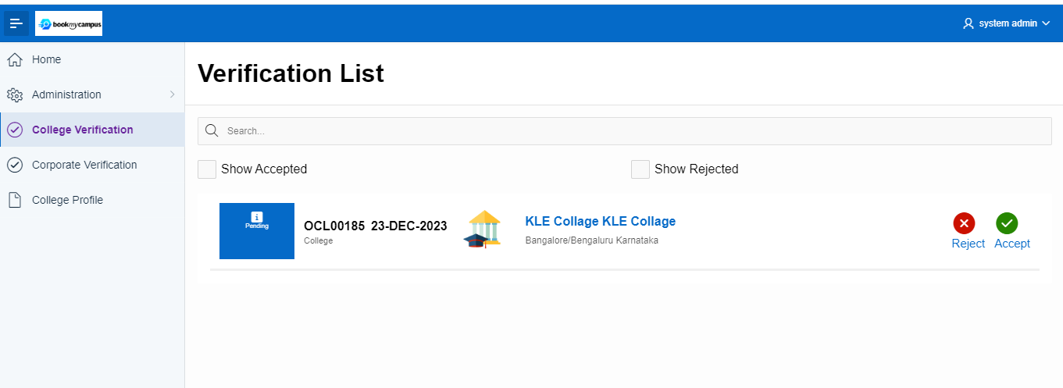

* Now collage admin user login using there credential as below.

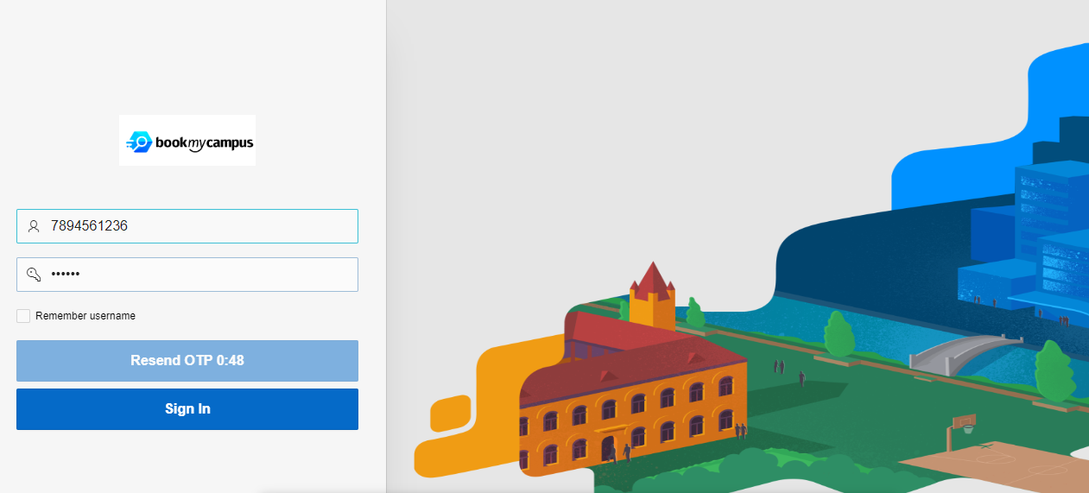

* Once collage admin profile is added to the BMC system following tabs will appear as below – (My Team, Calendar, Student upload history, Campus Booking Dashboard).

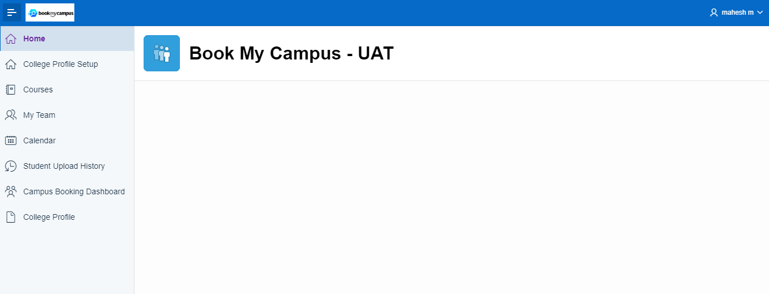

* Click Courses tab and add the New Courses.

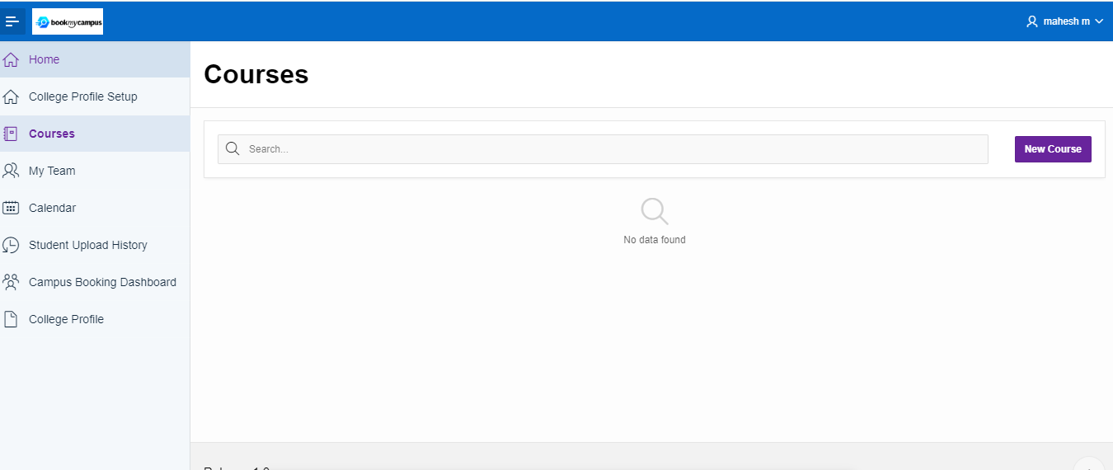

* If collage Prefers to add a new course it can be added by filling the details as shown below and click on Add Course tab.

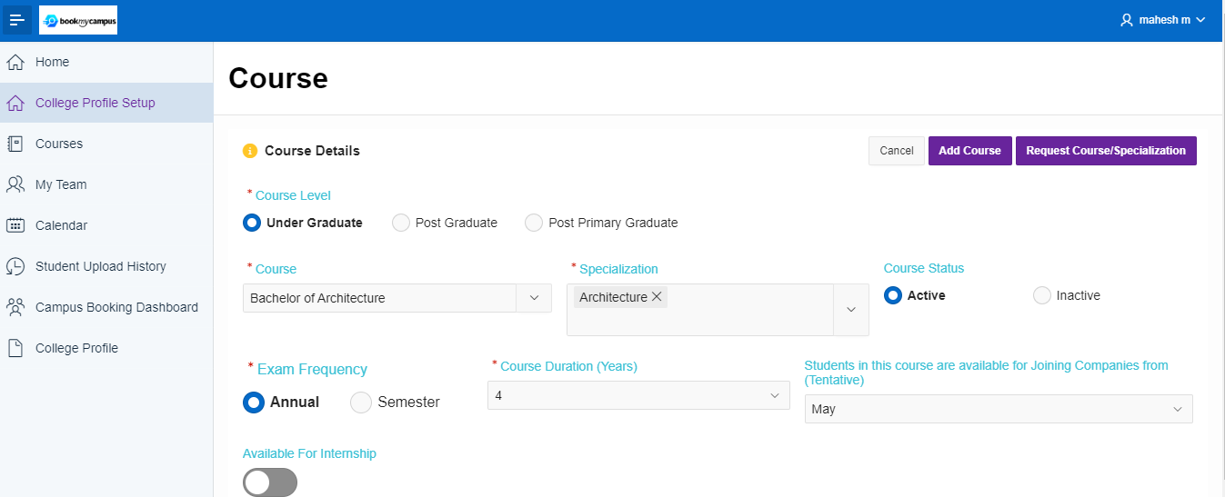

* Newly added course will be created as shown in below.

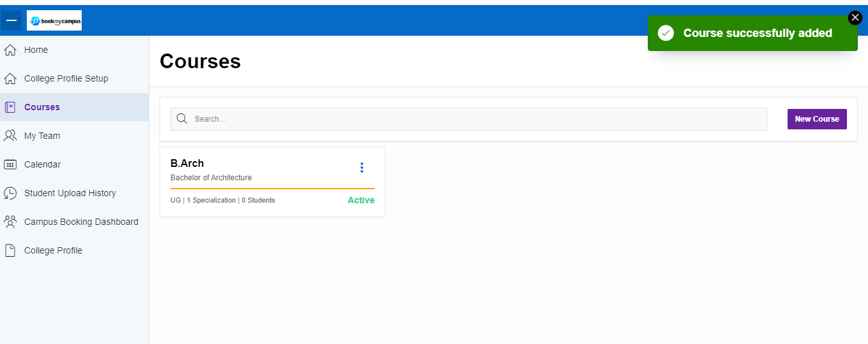

* Collage admin user can add other departments users under him if required.
* The above task can be done usin ‘My Team’ tab. And click on Invite User.

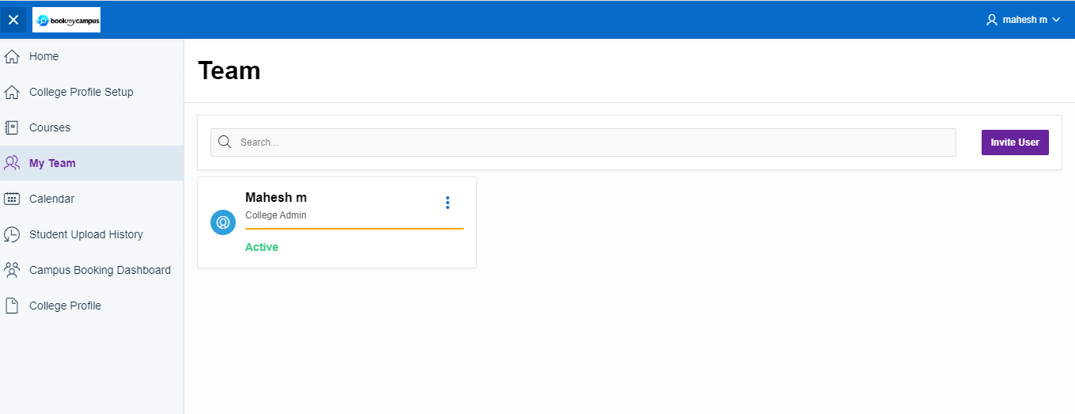

* Filling the all the required details and click the ‘Send Invite’ tab.

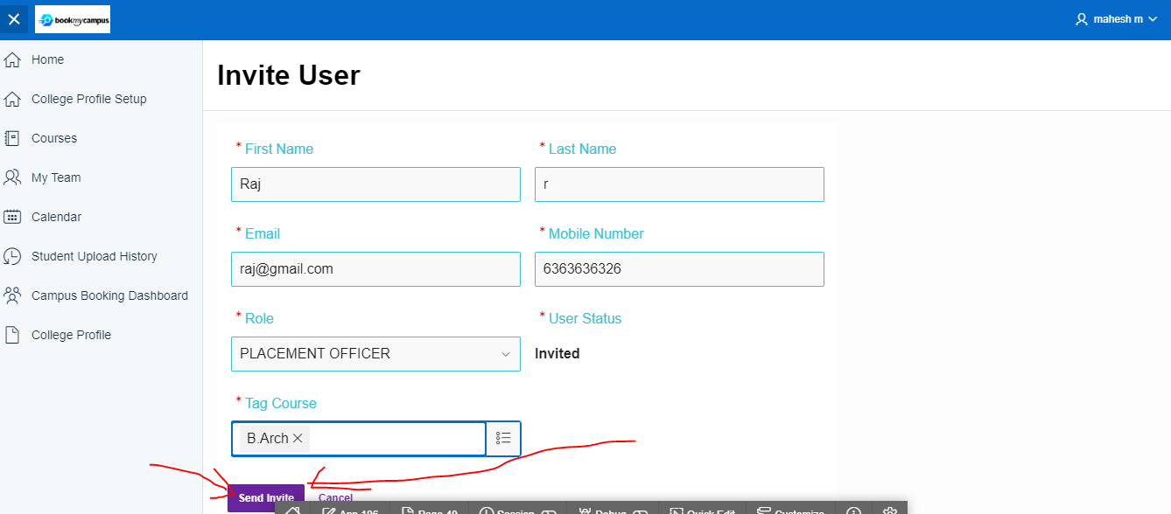

* New Team member successfully added.

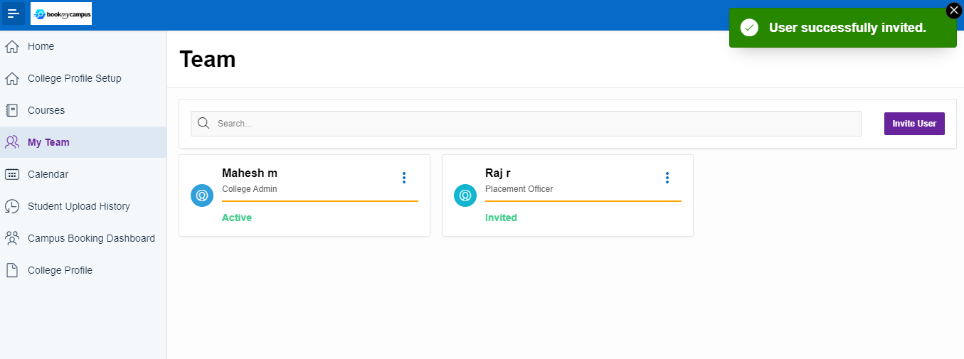

* For scheduling Campus hiring Calendar needs to be created as per the collage holidays/campus list.

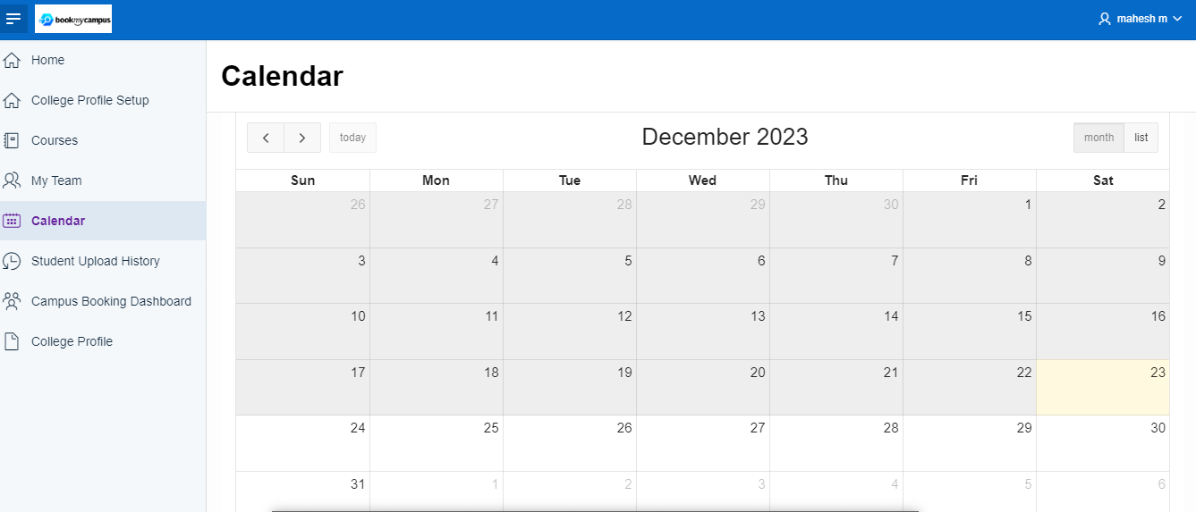

* Collage admin user can define the holiday date or campus inter date and click the save button.

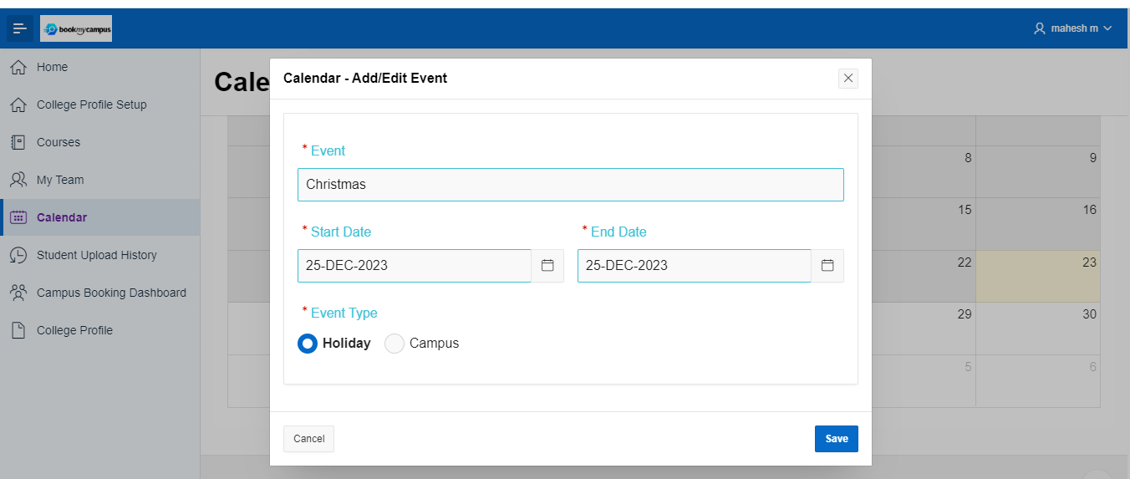

* Once the holiday/campus interview define in the system calendar will be marked RED colour.

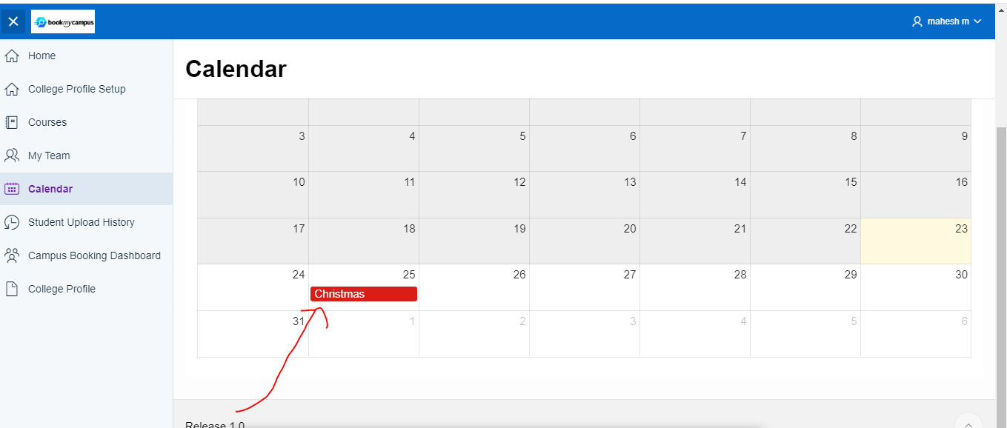

* If required collage admin he can revoke holiday/campus.

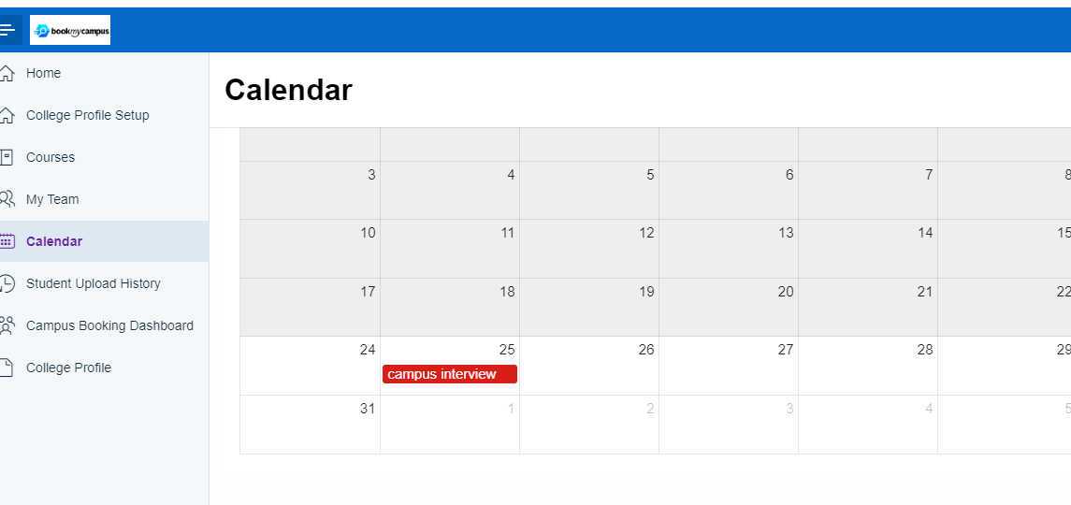

* Collage team member can login using their credentials which was created by collage admin user.

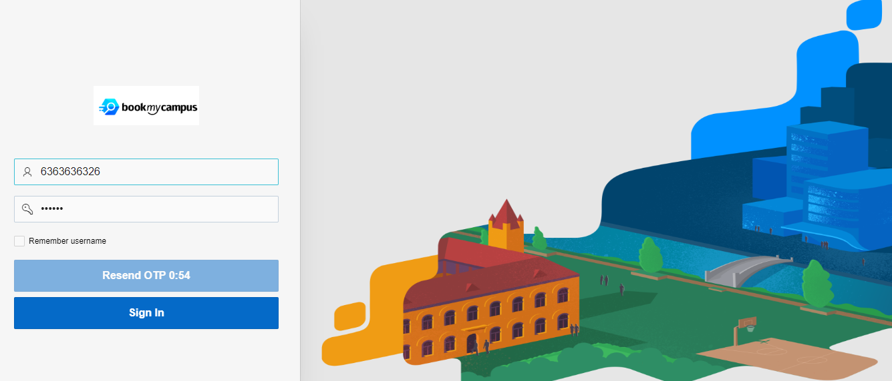

**CORPORATE MODULE :-**

* Corporate/Company can be created to the BMC system using Self Sign On as below by keying in mandatory fields .
* Click on the Create tab.
* Record will go to the BMC admin for reject/accept.

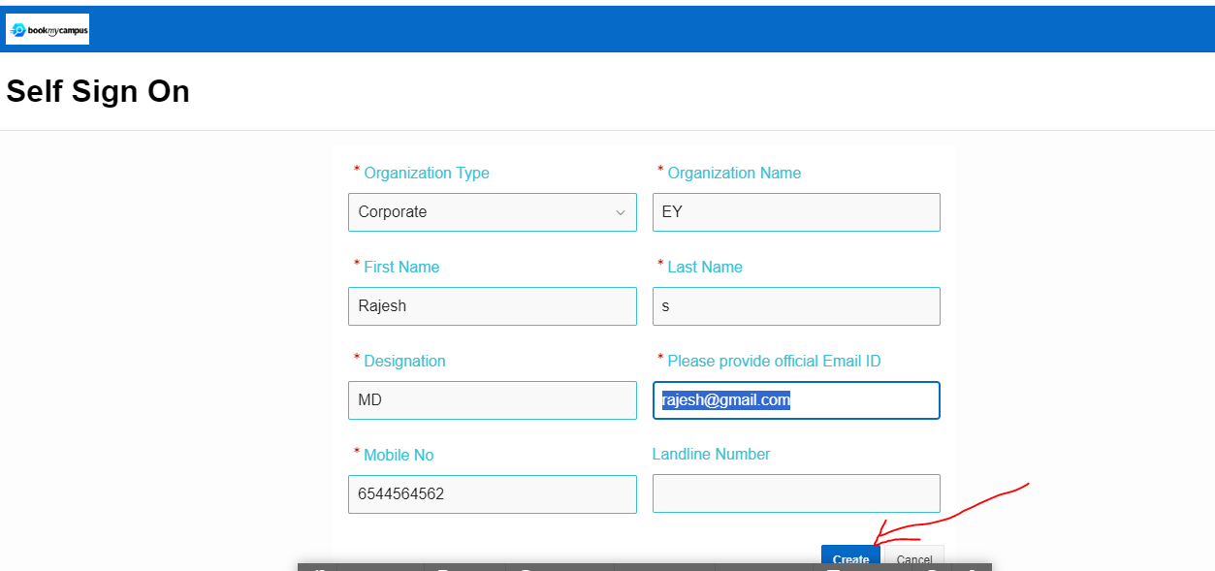

* User to check the mail accordingly login to BMC system as corporate admin user.

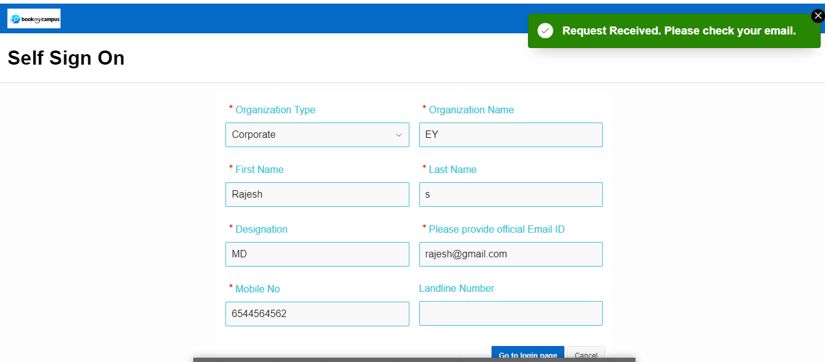

* Corporate admin user can log in to the BMC system by using their credentials.

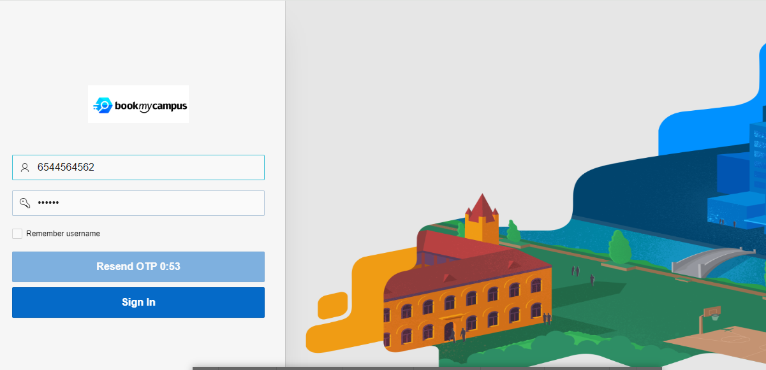

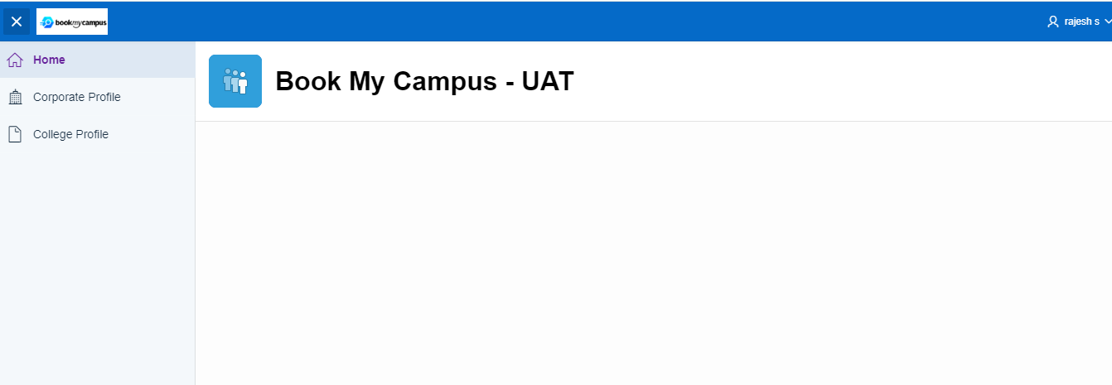

* Corporate admin to fill all the mandatory field which is present in Corporate profile – (Profile details, Location details, Media).
* Click on finish tab and corporate profile successfully saved message will appear.

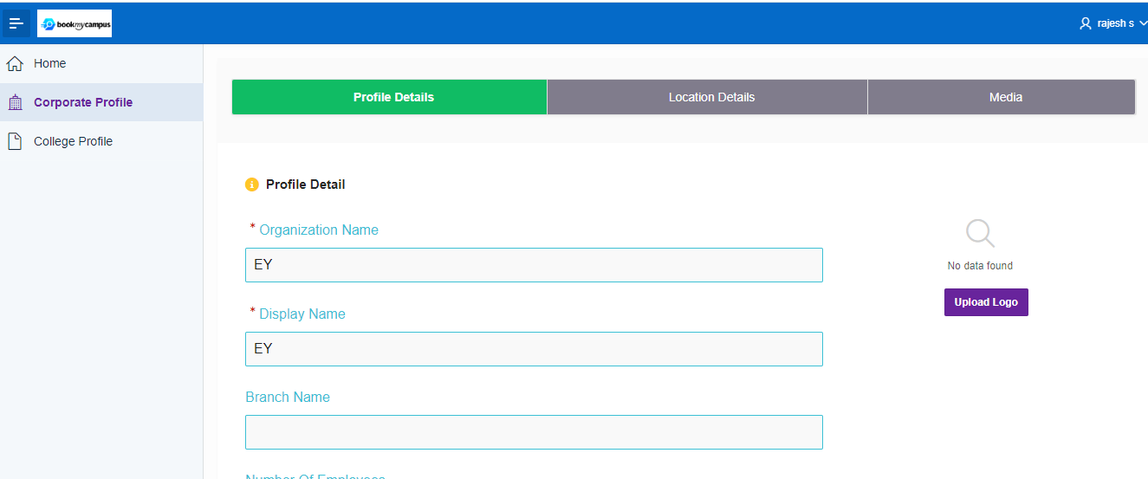

* BMC system Admin can Accept/Reject corporate user Request.

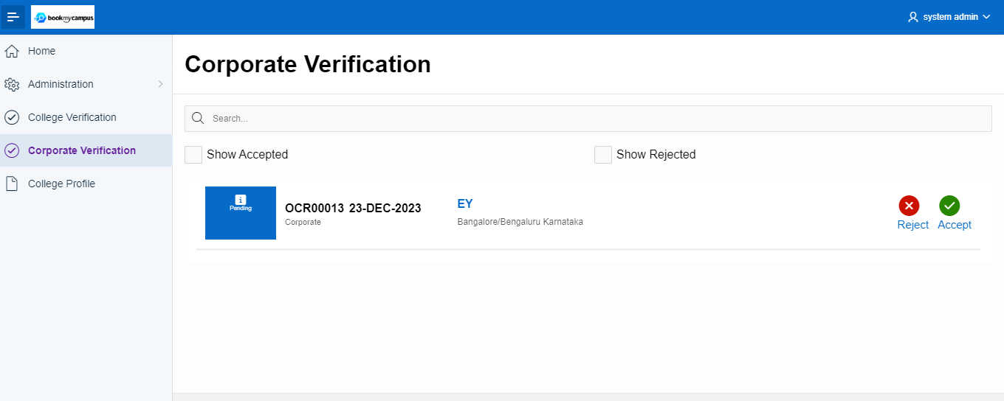

* Now Corporate admin user login using there credential as below.

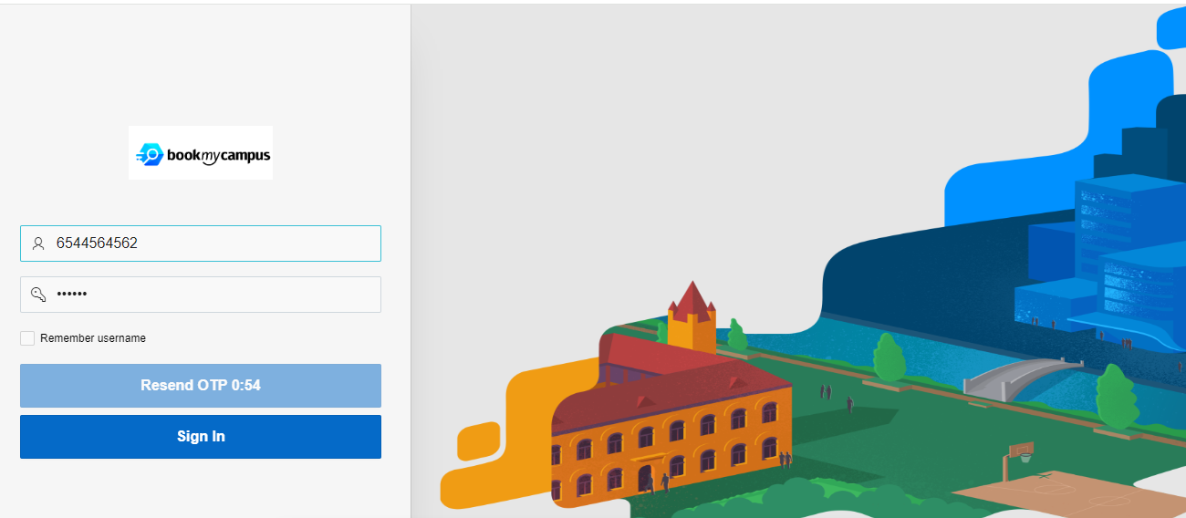

* Once Corporate admin profile is added to the BMC system following tabs will appear as below – (My Team, Job, and Event Dashboard).
* Corporate admin user can add other departments users under him if required.
* The above task can be done usin ‘My Team’ tab. And click on Invite User.

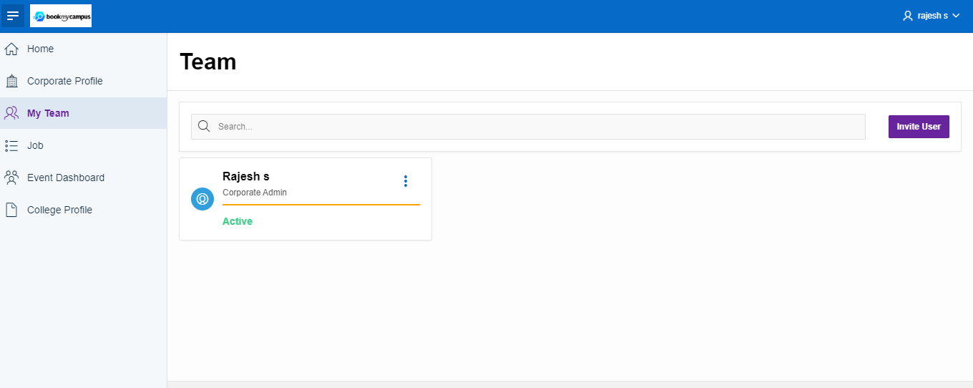

* Filling the all the required details and click the ‘Send Invite’ tab.

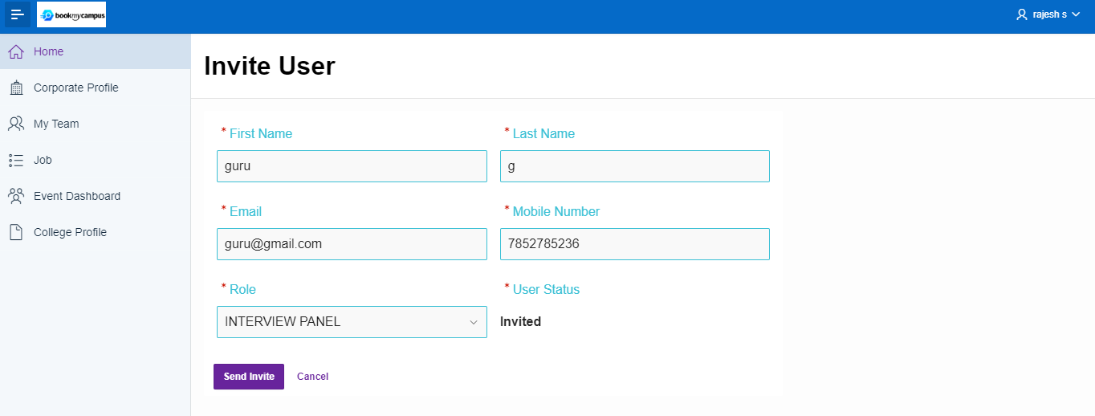

* New Team member successfully added.

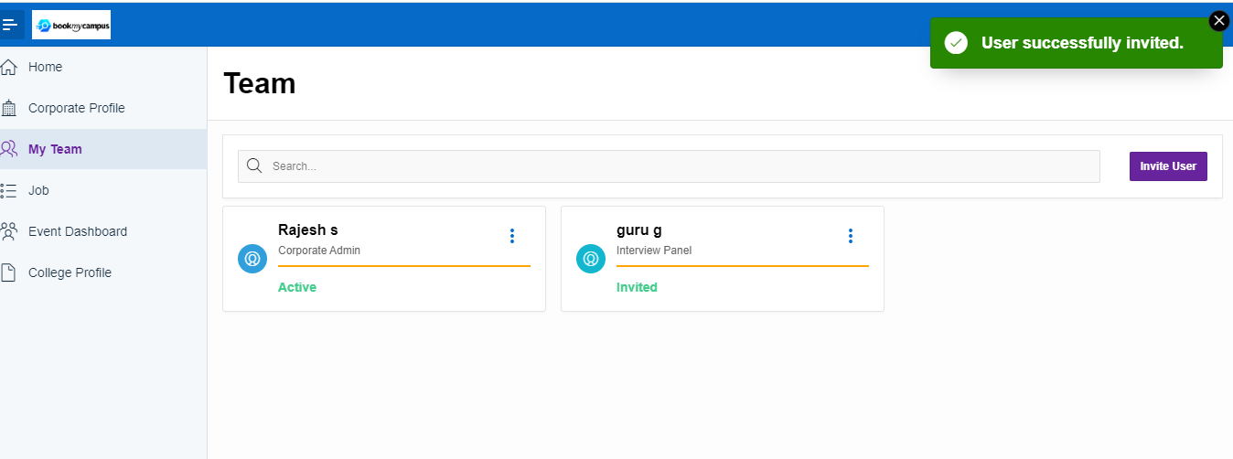

• Click Job tab and create the New Job Event.

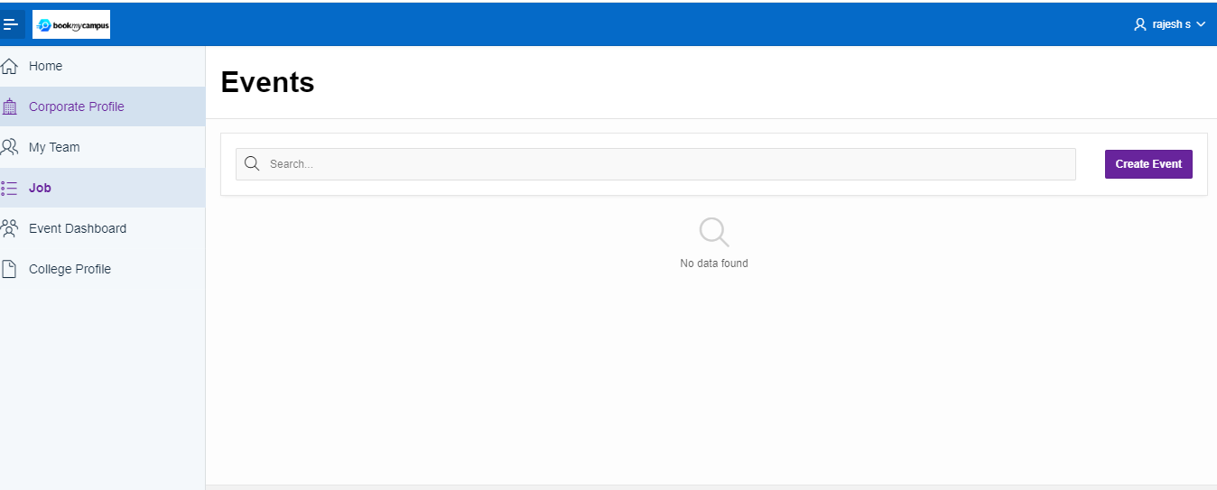

* If Corporate Prefers to create a new job event it can be added by filling the details as shown below and click on create Job tab.
* To fill all the mandatory field which is present in job -(Job details, Documents, Hiring Process, Eligibility Criteria, HR Contact).
* Fill the Job details.

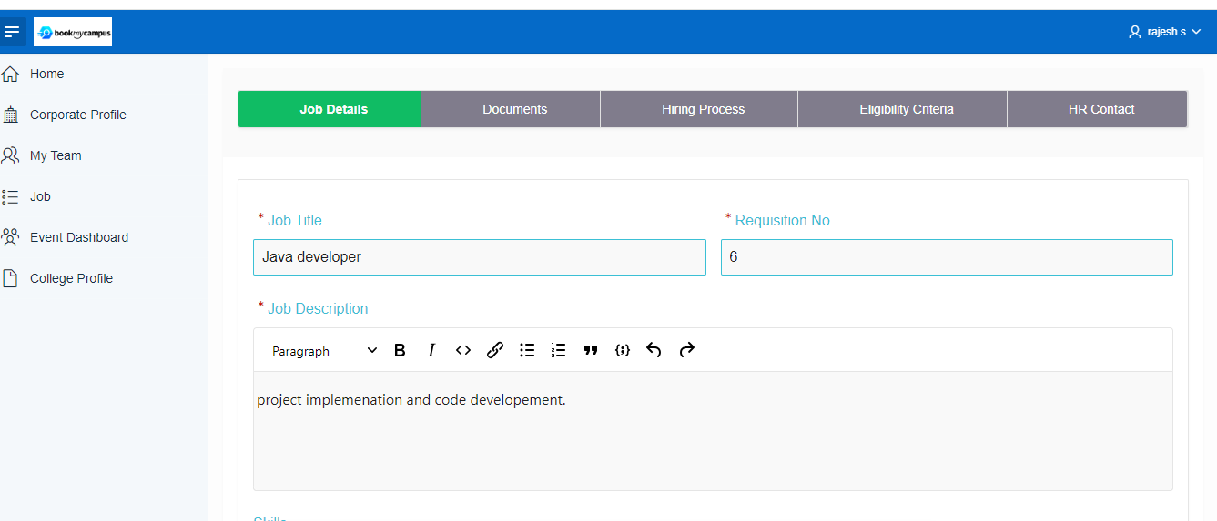

* Fill the Documents details.

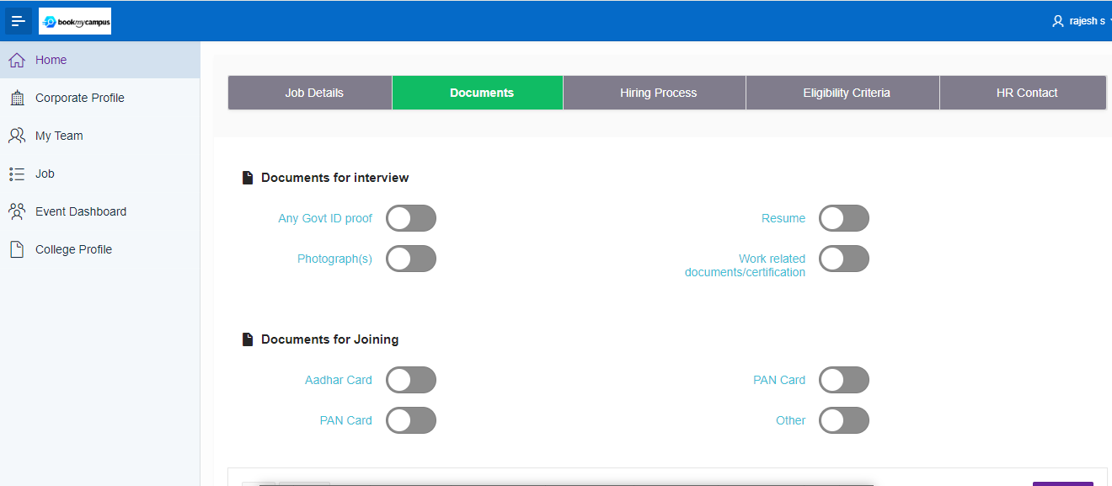

* Fill the Hiring Process details.

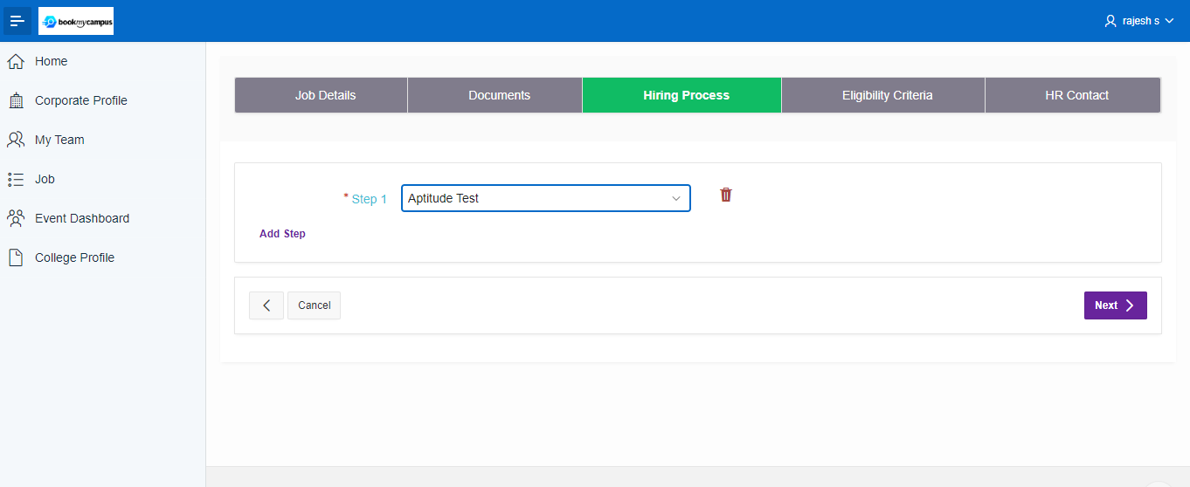

* Fill the Eligibility Criteria Details.

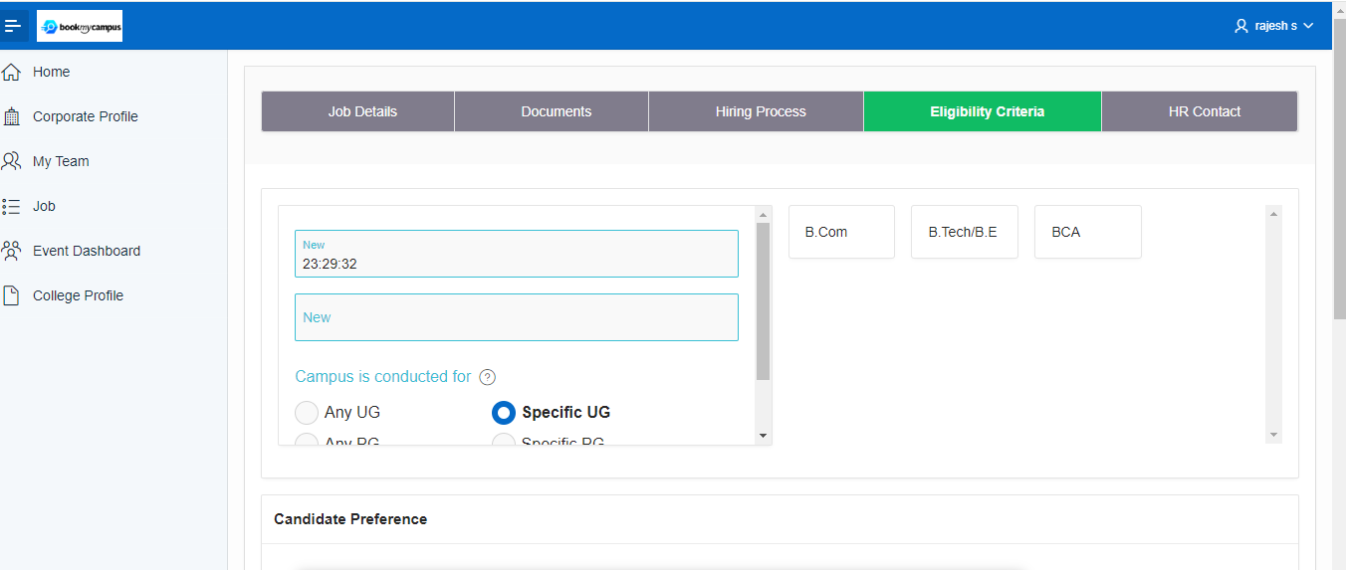

* Fill the HR Contact details and click on ‘SAVE’ tab.

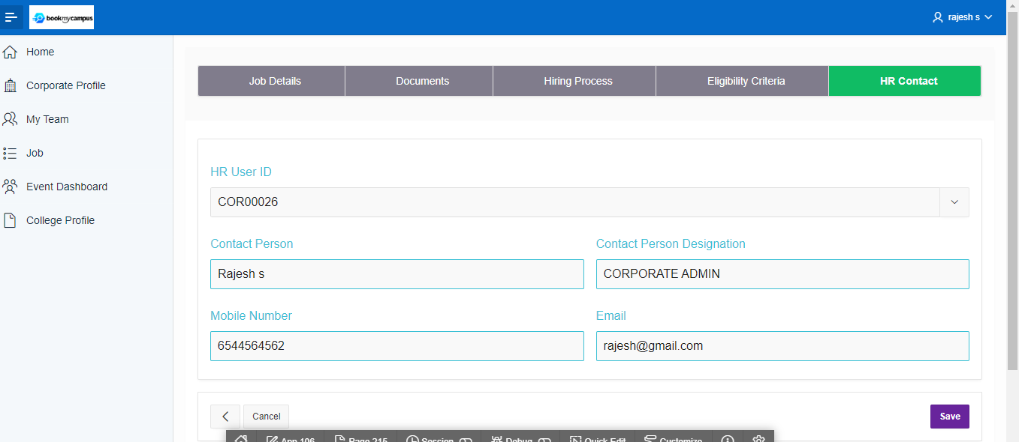

* Job successfully created. Next click on the ‘Find Collages’ tab.

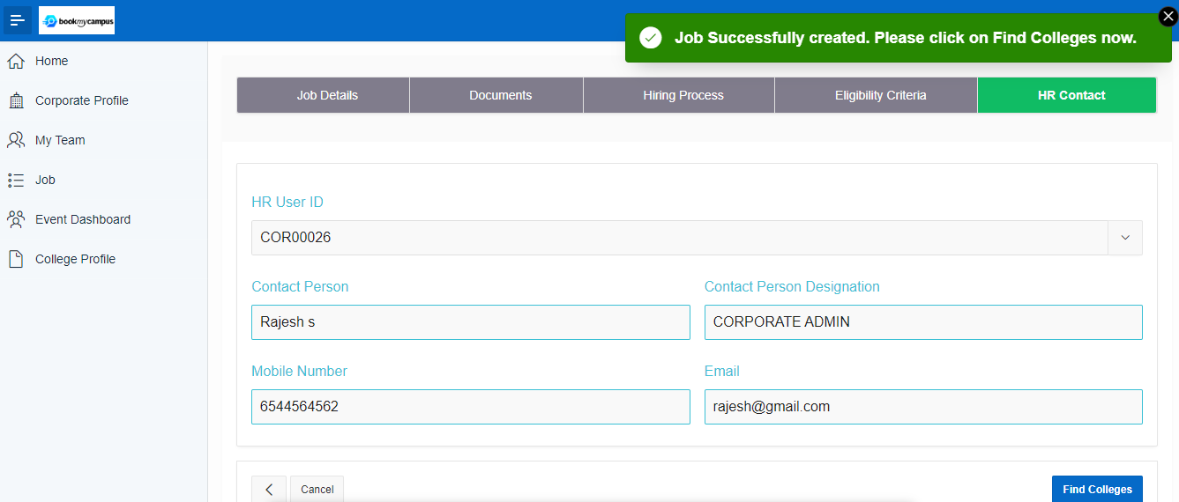

* Here select the Collages and click on the ‘Plan Dates tab’.

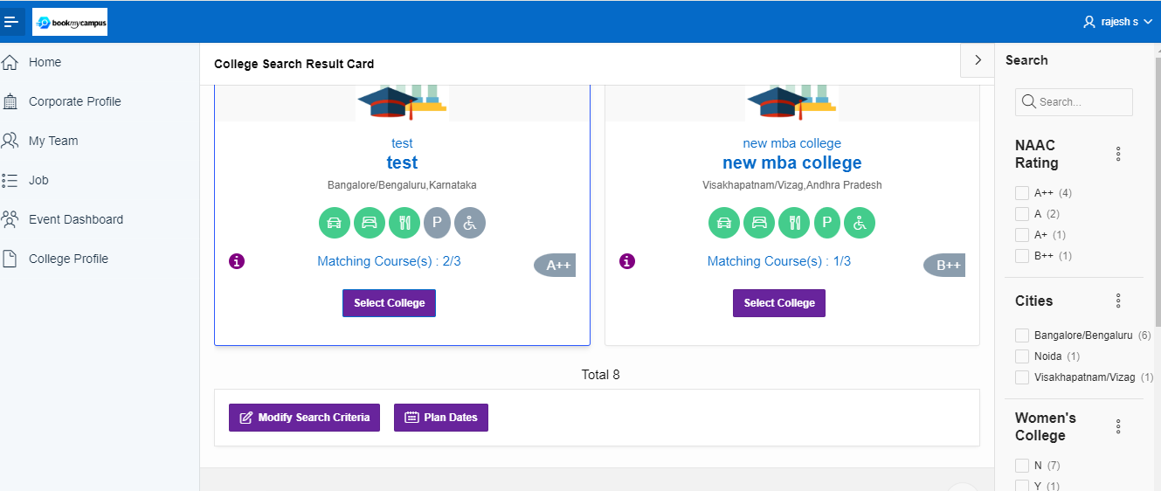

* Here select the Collage ID and select the campus date and click on ‘Publish dates to Collages’ tab.

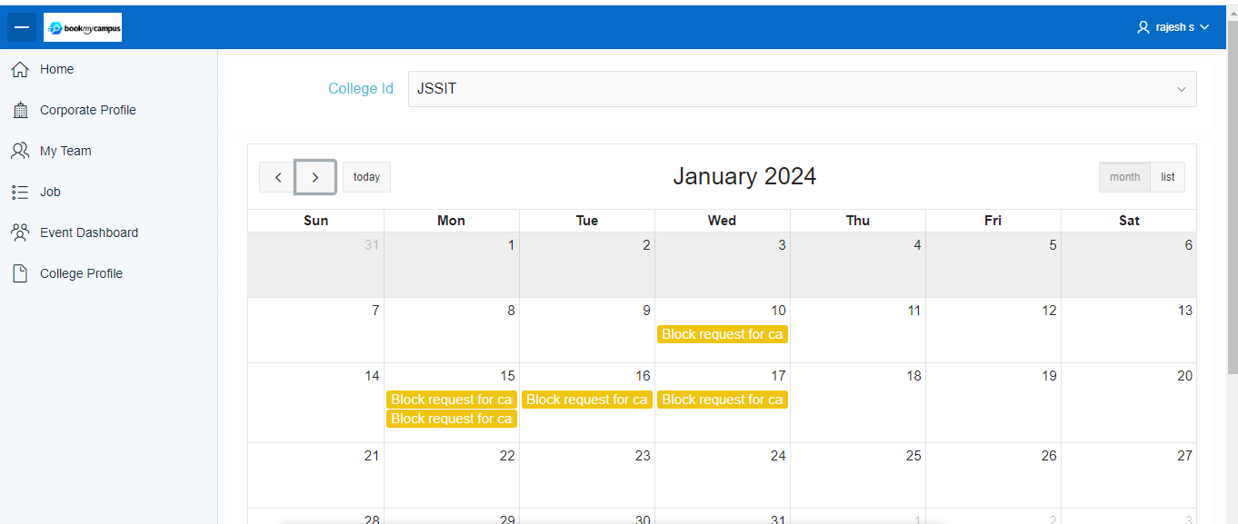

* Message will appear ‘Block request sent to collage for approval’.

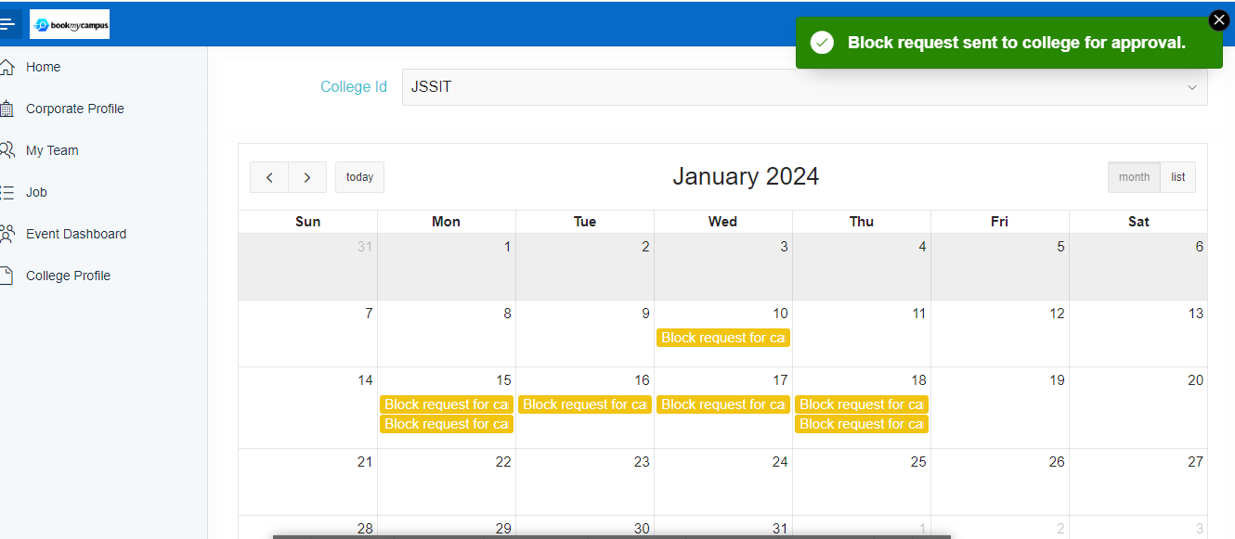

* Newly Created Job Event will be created as shown in below.

